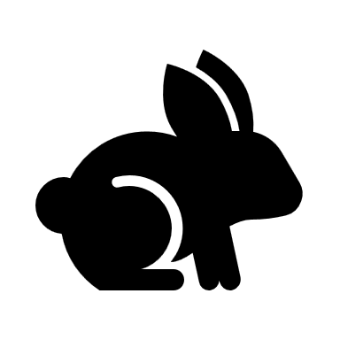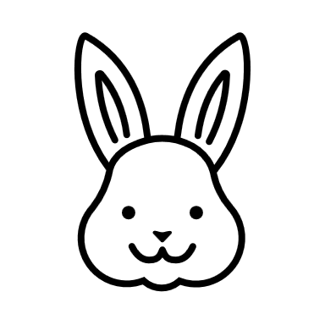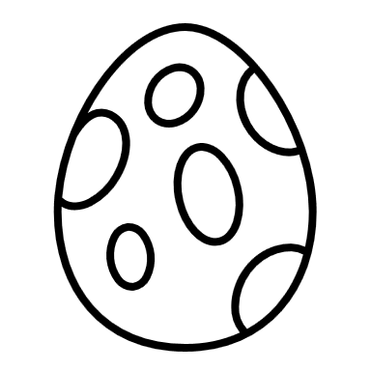 April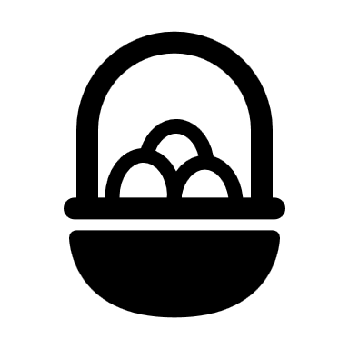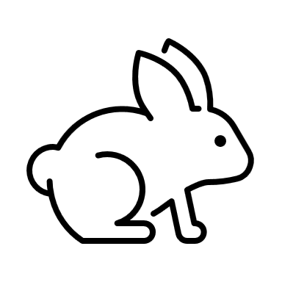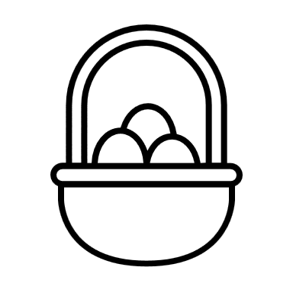 |  |  |  |  |  | Activity Calendar  Subject to Change
Sunday | Monday | Tuesday | Wednesday | Thursday | Friday | Saturday
Happy-Easter To All Care Team Members And Residents | # Outside  Activities will be held in Light House Dining Room | What kind of jewelry is the best Easter gift?  A 14-carrot gold necklace | What's an Easter egg's least favorite day?  Fry-day | 1 Happy April fools day!!  9:30 Current Events  10:00 UNO  1:15 Yahtzee  3:15 For Get It  6:00 Sand Art | 2  9:30 Coffee News  10:00 Dominoes  11:00 Table-Talk  1:00 Rummikub  3:15 Trivia-Music | 3  9:30 Coffee Music  10:00 Nail Care  1:15 Easter Cookies Decorating  3:15 LRC
4-Happy Easter  9:00 Church-TV  10:00 Clue  1:15 Outside Corn-Hole-if warm#  3:15 Rummikub | 5  9:30 Music Coffee  10:00 Dominoes  1:15 Kings in the Corner  3:15 LRC | 6  9:30Current Events  10:00 Yahtzee  1:15 Resident Council in Light house Dining Room  6:00 Wii Games | 7  9:30 Current Events  10:00 Uno  1:15-Water Works  3:15 Crafts | 8  9:30 Current Events  10:00 Dominoes  1:15 For-Get-It  3:15 Skip-Bo  6:00 Name that Tune | 9  10:00 Crafts  11:00 Room Visit  1:15 For-Get-It  3:15 Name that old TV Show | 10  9:30 Coffee News  10:00 Shop West  1:15 Jumbo Dominoes#  3:15 Yard Yahtzee #
11  9:30-Church TV  10:00 Nail Care  1:15 Bingo Front  3:15 Bingo Front | 12  9:30Music Coffee  10:00 Deer in the Headlights  1:15 Uno  3:15 Liars dice | 13  9:30 News/Coffee  10:00 Yahtzee  1:15 Dominoes  3:15 LRC  6:00 Card of Choice | 14  10:00- National Pecan Day  1:15-Gardening Day  2:15-Trivia  3:15-Finish Gardening | 15  9:30 News Coffee  10:00-Wild Guess Day  1:15 - Bat-Balloon  3:15-Bowling#  6:00 Necklace Crafts | 16 National PJ Day  9:30 Current Events  10:00 Mr. Lister  11:00-Room Visits  1:00 Kings in The Corner | 17  9:30 Coffee Music  10:00 Shopping-South  1:15 Bingo-Back  3:15 Bingo-Back
18  9:30 Coffee Music  10:00 Wheel of Fun  1:15 Outside Art Class#  3:15 Bowling | 19  9:30 Coffee News  10:00 Dominoes  1:15- Yahtzee  3:15 Rummikub | 20  9:30 Music  10:00 Sand-Art  1:15 Skip-Bo  3:15 Outside Corn-Hole  6:00 Wii Games | 21  9:30 Music Coffee  10:00 Dominoes  1:15-Crafts  3:15 Yahtzee | 22  9:30 Music Coffee  10:00-Uno  1:15-Sand-Art #  3:15 For-Get-It  6:00 Movie popcorn | 23  9:30 Music Coffee  10:00 Crafts  11:00 Table-Talk  1:15-Clue Suspect Cards | 24  9:30 East-Shopping  10:00 Shopping North  1:15 Yard Yahtzee #  3:15 Crafts #
25  9:30 Coffee-News  10:00 Nail Care  1:15 Uno  3:15 LRC | 26  930 Music-Coffee  10:00 UNO  1:15 Po-Ke-No  3:15 Kings In The Corner | 27  930 Current-Events  10 For Get It  1:15 Yard Darts  3:15 Uno  6:00 Dominoes | 28- Outside#  9:30 Table-Talk  10:00 Yahtzee  1:15 Wheel of Fun  3:15 Hang Man | 29  9:30 Music with John  10:00 Parachute-Game  1:15 Sand Art  3:15 Bowling#  6:00 Hedbanz | 30 National Oatmeal cookie day  9:30 Music and News  10:00 Cooking Class  1:15-LRC  3:15 Skip-Bo | What happens if you tell a joke to an Easter egg?  It cracks up

